
City of Sherrill
Spring 2018 Newsletter
Please visit www.sherrillny.org and sign up for our email list to receive notifications about events, programs and services.


From the City Manager, Brandon M. Lovett
Dear Sherrill Residents,

We are close to ending another long winter season here in Central New York and spring is right around the corner. Like many I am looking forward to getting back outdoors and enjoying our beautiful region. I also look forward to meeting more residents and welcome your thoughts and ideas about our City. The City recently conducted community meetings about recreation facilities, programs and events, and about economic development with Mohawk Valley EDGE. The purpose of these meetings was to engage those interested in opportunities in both areas. As City Manager I am always receptive to additional ideas for community engagement meetings. If you have ideas for future discussions, please let me know.

The City makes every effort to communicate with our residents in many ways. This newsletter is an important means of communication and contains a lot of helpful information for Sherrill residents. Another important resource for residents is the City website: www.sherrillny.org. Our website is home to information about City services, it contains contact information for City officials, agendas and minutes for City meetings, and key reference documents such as City ordinances and the City charter.

Like most things technological, communication is rapidly developing and changing. The City’s Facebook page is very active and offers a plethora of information on programs, events, news and beyond. The City is always looking for ways to better communicate and serve our community. If you have any suggestions or ideas I ask that you please share your thoughts with us so we can brainstorm about how to better serve the public. If you have questions or concerns you are always welcome to contact me or your City Commissioners. My email address is blovett@sherrillny.org. There is also a public comment portion of each Commission meeting where members of the public may address the Commission on any matter of concern. The Commission meeting dates are listed on the City’s website. We welcome and value your involvement.

Enjoy the spring season!

Regards,
Brandon

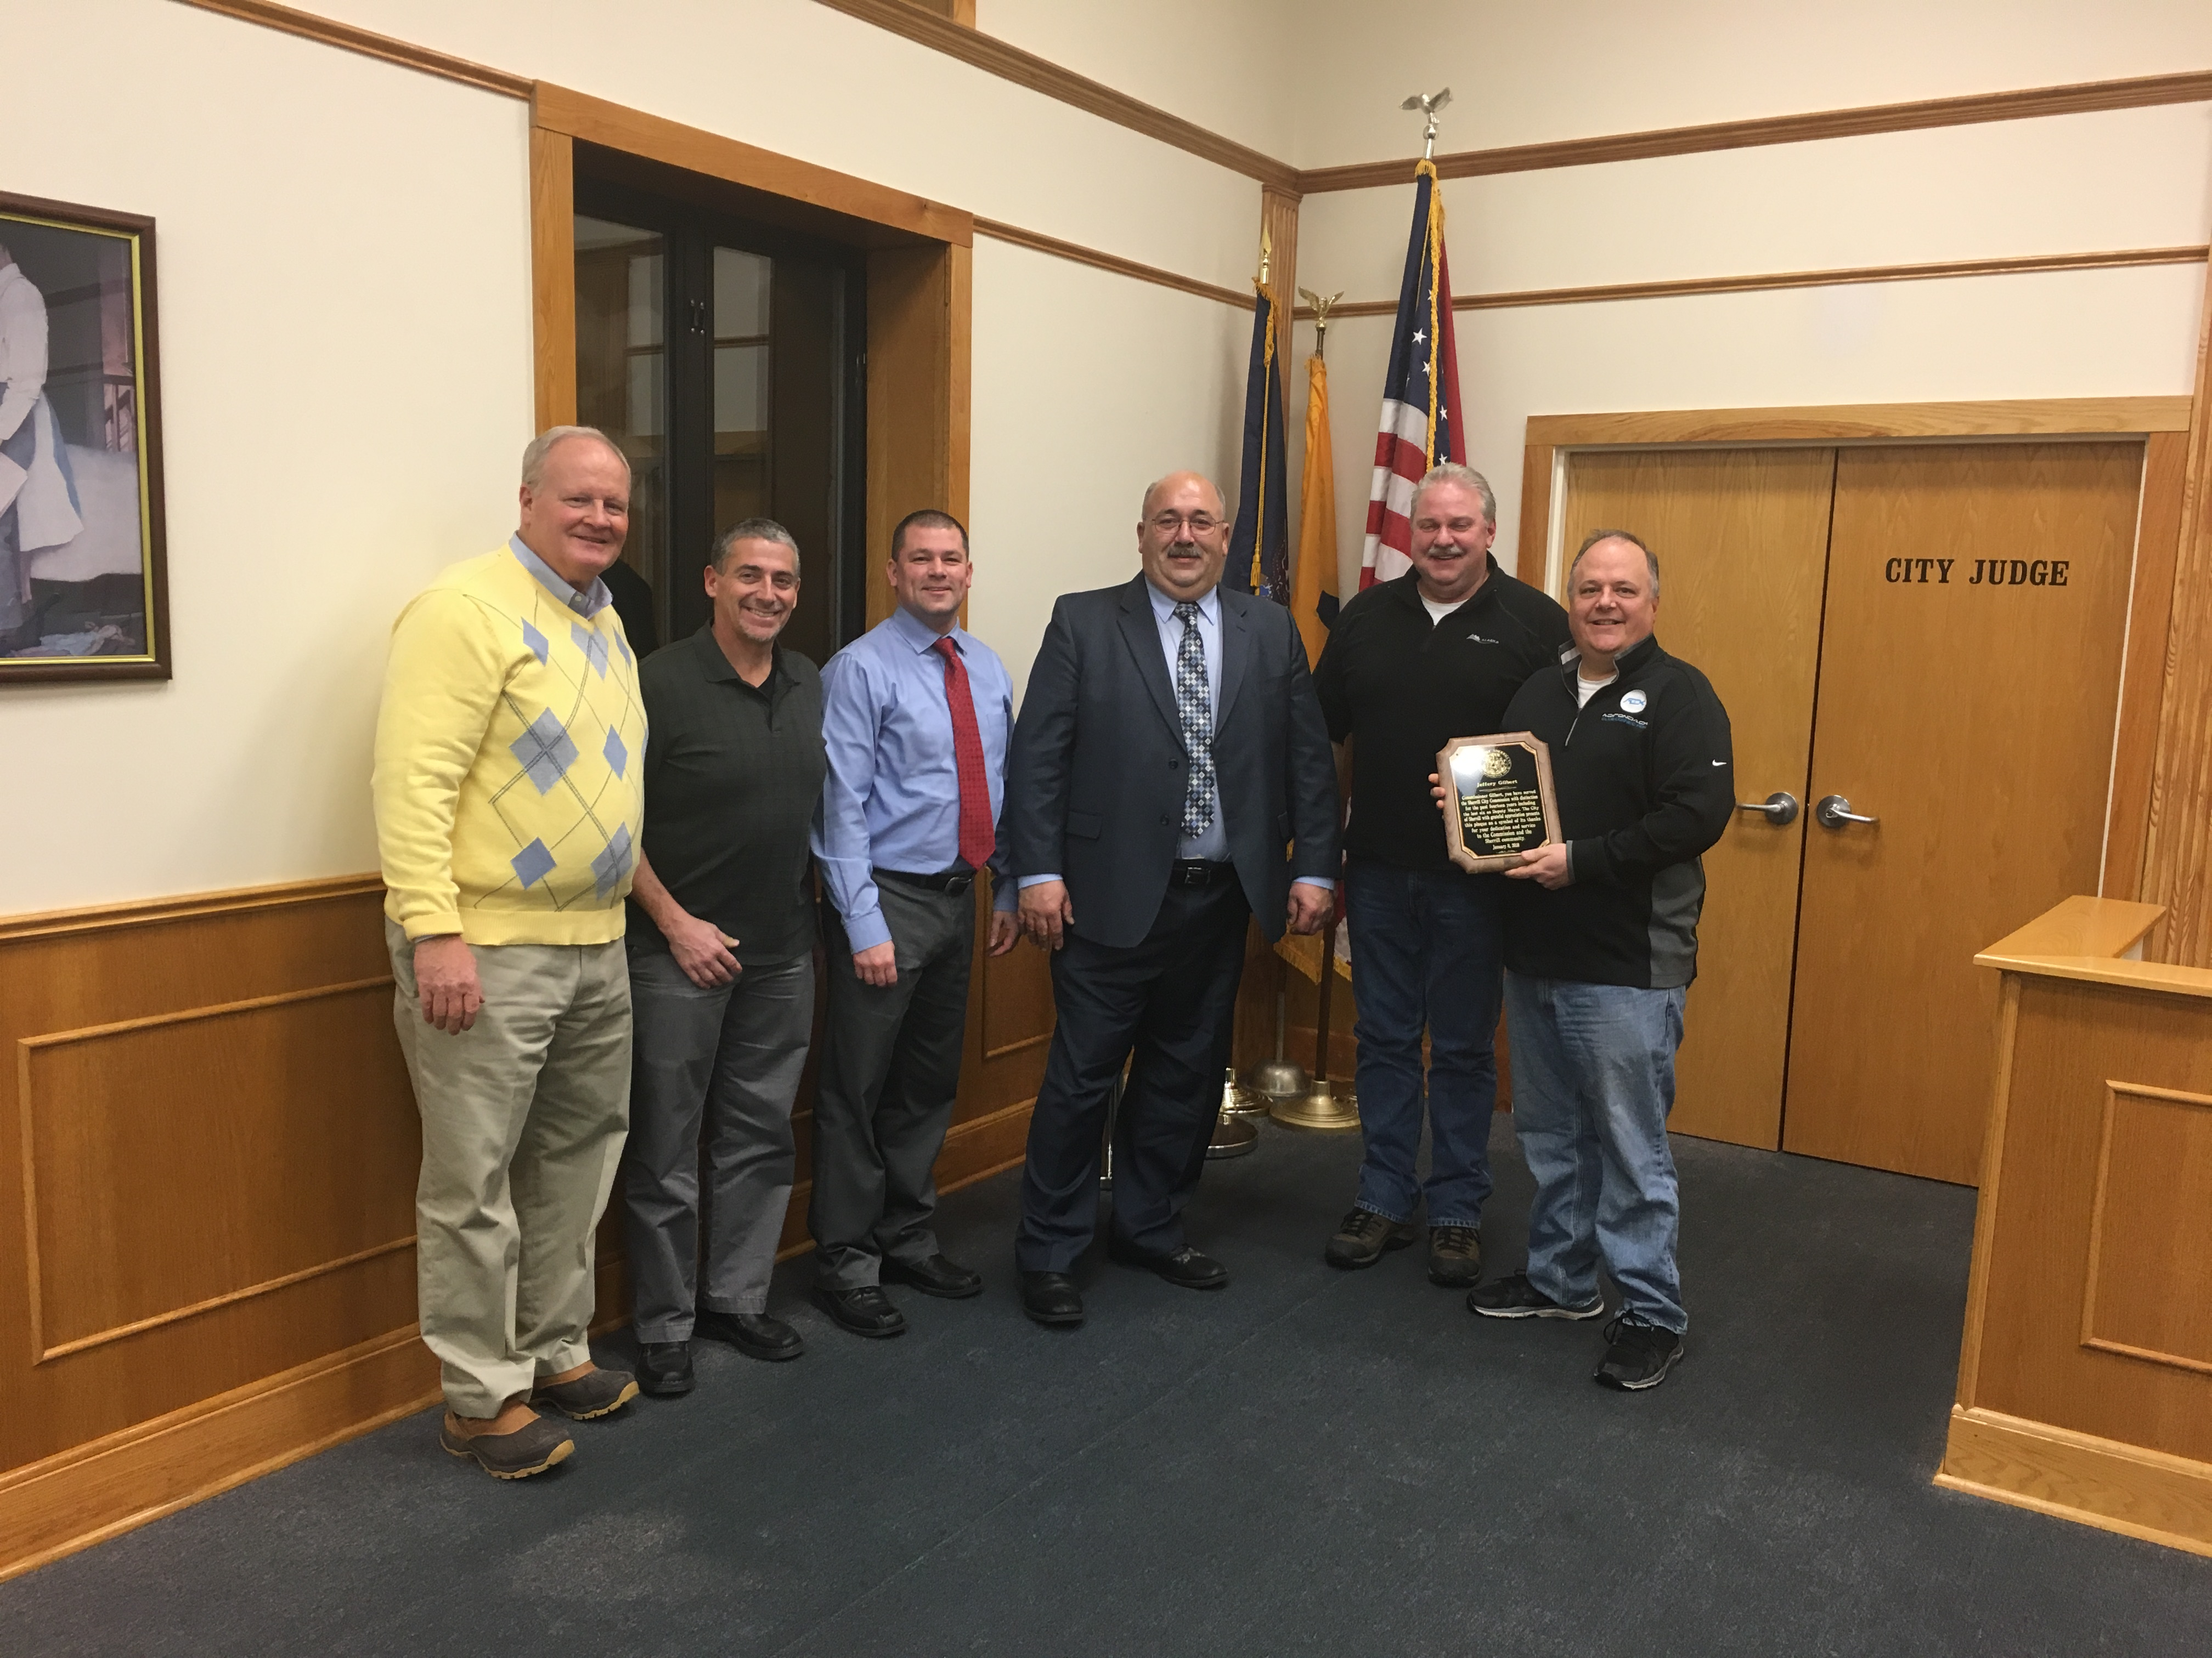

A new, but familiar, face joined the Sherrill City Commission earlier this year. Commissioner Joseph Shay was elected in November 2017 to the City Commission. Commissioner Shay replaces long time Commissioner Jeffery Gilbert who chose not to run in 2017. Commissioner Shay previously served on the Commission from January 1, 2000 through December 31, 2011 and served as Mayor for the last ten years of that term. On behalf of the City of Sherrill, welcome back Joe! The City would also like to extend our thanks and gratitude to Jeff Gilbert for 14 years of service and commitment to the City.

Inside

City Contact Information &
Fire Department News page 2

Recreation & CAC News page 3

Department of Public
Works News page 4

Sherrill-Kenwood Library News page 5

Local Business &
Organization News page 6

Police, Assessor, Memorial
Day & Organization News page 7

City of Sherrill
Contact Information
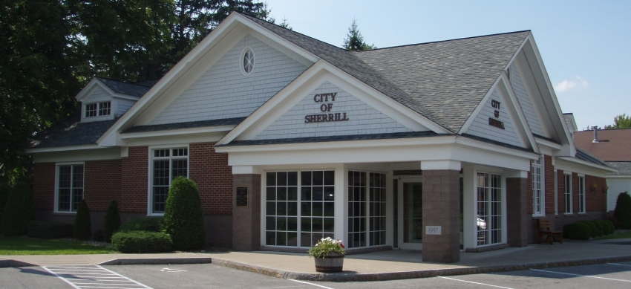

City Officials

Brandon Lovett, City Manager
(315) 363-2440, blovett@sherrillny.org

Michael Holmes, City Clerk/Comptroller
(315) 363-2440, mholmes@sherrillny.org

City Commissioners

William Vineall, Mayor
(315) 366-5430, mayor@sherrillny.org

Jason Merrill, Deputy Mayor
(315) 886-6998, jmerrill@sherrillny.org

Tom Dixon
(315) 363-1890, tdixon@sherrillny.org

Patrick Hubbard
(315) 363-3379, phubbard@sherrillny.org

Joseph Shay
(315) 363-9234, jshay@sherrillny.org

Other City Phone Numbers

City Hall, (315) 363-2440

CAC, (315) 363-6525

Power & Light, (315) 363-0780

Police Department- Please note these numbers and use the correct one for efficient response.
Emergencies- 911
Dispatch- (315) 363-3200
Leave a message- (315) 363-6221

From the Sherrill-Kenwood Volunteer Fire Department

Membership- The fire department is always looking for new members, especially junior members! If you’re interested in firefighting, EMS, or scene support and are 18 years of age or older for regular membership or 16 years old for junior, please visit the fire station during our Wednesday Night Drill that starts at 6:50pm, every week, for details.

Spring Tips
-Change smoke detector and carbon monoxide batteries. Carbon monoxide is the most common cause of death by poison in the U.S., killing more than 500 people each year. It’s one of the most dangerous poisons because often people don’t know it’s present until it’s too late. A working carbon monoxide detector can provide an early warning before deadly gases build up to dangerous levels. If you live in a home that’s two stories or more, you may want to install two. Also, change out detectors that are older than ten years for new ones.
-Make sure your address numbers are up and visible from the street. Having your address clearly visible will aid the fire department in finding your house quickly! Every second counts!
-Check fuel containers for leaks & make sure they’re properly stored.
-Due to warming temperatures and dry conditions, residential brush burning is prohibited March 16-May 14 across New York State. The burn ban reduces wildfire risks and protects lives and property.
-Do not discard cigarette butts in landscaping mulch or peat moss. The resulting fire can smolder, travel, and be small enough to not be noticed until it reaches porches, houses, or businesses.

Prevent Falls
-Clean up clutter- Keep your home tidy. Remove clutter such as stacks of newspapers and magazines, especially from hallways and staircases.
-Repair or remove tripping hazards- Examine areas for loose carpet, slippery throw rugs, or floorboards that stick up and fix those items.
-Install grab bars and handrails- These devices are crucial for stairs and bathrooms. Have a handyman or family member help if necessary.
-Avoid loose clothing- You want to feel comfortable but baggy clothes can sometimes make you more likely to fall. Opt for better-fitting and hemmed clothing that doesn’t bunch up or drag on the ground.
-Light- Install brighter bulbs in stairways and hallways. Add night lights in bedrooms and bathrooms.
-Wear shoes- Socks can present a slipping risk. Wear shoes or purchase non-slip socks that have grips on the soles of the feet.
-Make it nonslip- Bathtubs, showers, floors in kitchens, bathrooms, and on porches can become dangerous when wet. Use nonslip mats.
-Move carefully- Many people fall after moving too quickly from a sitting to a standing position and vice versa. Pause after going from lying down to sitting and from sitting to standing. Also pause before using the railing on stairs, whether going up or down.

Sherrill Recreation and Community Activity Center News
139 East Hamilton Ave, (315) 363-6525, Call or visit www.sherrillny.org for more information!

Recreation Meeting
We held a meeting last fall for residents to share ideas about parks, events, etc. The scheduled follow up meeting in February was cancelled due to snow. Join us Wednesday May 16 at 6pm upstairs at the CAC for a follow up meeting. All are invited!

Daily Activities
-Indoor Walking in the Gym- Open to all, weekday mornings, 8-9am.
-Kids Time- Children ages 5 and younger who are supervised by an adult are invited to play in the gym Monday-Friday, 10am-12pm. *Times may change due to special events. Contact the CAC for updates.

Spring Events at the CAC
Spring Craft Show- April 7, 9am-3pm
Bowling Tournament- April 12-14
VVS Education Foundation Garage & Pie Sale- April 28, 9am-1pm

Open Bowling Hours
Wednesdays 10am-12pm, Fridays 6-11pm, Saturdays 1-5pm & 9:30-11pm,
Sundays 12-5pm- *These hours will end April 29. Throughout the spring/summer there are limited hours at the CAC. Please call for updates. Cost: $3.25/game, $1/shoes

Adult & Student Spring Bowling Leagues- Leagues will bowl April-June. Please call for information.

Billiards- Call for details about leagues. Anyone 16 or older can play when the CAC is open, and tables are available. Cost: $2/half-hour

Graduation Parties and Private Events- The gym and upstairs are available to rent for parties, showers, meetings and other events. Visit www.sherrillny.org/recreation/cac/ for more information.

April Break Activities at the Sherrill Community Activity Center


Monday & Tuesday April 23 & 24- Sports & Crafts, Gym & Outside, 10am-12pm- for K-6th grade kids who live in Sherrill or attend McAllister school, *Registration is required. Forms will be distributed at McAllister and are available at www.sherrillny.org.

Wednesday April 25- Free Family Open Gym, 9am-12pm- Play in the gym! Kids 14 & under must be supervised.


Thursday-Sunday, April 26-29- Open Bowling- Thursday 12-4pm, Friday & Saturday 12-11pm, and Sunday 12-5pm. *From 12-2pm each day kids 14 & under bowl free and everyone else pays $5 for two games and shoes (limit 2 games).



Ongoing Classes, Groups and Events
Mondays- Bone Builders- Strength Training for the Older Adult, 9am Contact Polly, (315) 853-6258 for details, $1.50/class.

Tuesdays
-Arts Guild- Join these artists 9am-12pm to paint, share ideas, and critique.
-Free Family Open Gym Time- Residents are invited to use the gym from 5-6pm at no charge. Kids 14 & under must be supervised.

Wednesdays
-Oneida County Office for the Aging- A representative is at the CAC the first Wednesday of the month at 11am to provide services. Stop by or call Emily Comito, (315) 768-3623.
-CAC Craft and Chat Group- Join this group the 1st, 3rd & 5th Wednesday of the month, 11am-1pm, to knit, sew, or create any craft.

Thursdays- Rescue Me K-9 Dog Rescue Dog Socialization- These are free classes from 6-7pm for anyone who wants to bring their dog. Donations are accepted. Call Debbie Martin, (315) 829-3454 with questions.


News from the Department of Public Works
Crews have begun planting trees and flowers, installing new street signs and using the street sweeper. They’ll also be installing a new scoreboard, new fencing and manicuring fields at our parks. As this year’s sidewalk replacement and roadwork commence, the City is already shining!

Garbage Pick-Up Change- Pick up for Monday 5/28 will take place Tuesday 5/29.

Common Garbage & Recycling Mistakes
Overweight- Garbage may not weigh over 40 lbs., recyclables 20 lbs.
Size- Containers must be 10-32 gallons.
Damaging Materials- Construction debris & oversized materials are not accepted.
Plastic Bags- Although some bags have a recycling triangle, they can’t be recycled via our program. Bags can be brought to most grocery stores for recycling/reuse.
Food Still in Recyclables- Examples- remove pizza from box, rinse containers.

Brush & Green Waste Pick-Up- every other Monday April 9-October 22 (4/9, 4/23, 5/7, 5/21, 6/4, 6/18, 7/2, 7/16, 7/30, 8/13, 8/27, 9/10, 9/24, 10/8, 10/22) Please do not place waste at curb prior to the weekend before pick-up and do not place it in the roadway, near wires, or on top of exposed water or gas valves. Piles must be free of garbage, soil, rocks, animal waste, lumber, etc., and not be placed in any type of twine, container, bag, etc. Brush must be less than 6’ long and 4” wide.

Lawn Care- Clippings can be left on the lawn and not raked so soil receives nutrients. Use of fertilizer can be eliminated by using this natural nitrogen.

Compost- is available for residents to take at the end of Fairway Lane, adjacent to the Waste Water Treatment Plant.

Transfer Station Hours- Saturdays- 8am-1pm, Wednesdays- 4-7pm (April 4-early fall). Residents must purchase coupons at City Hall to drop things off. The number of coupons varies based on the size of the load. Visit www.sherrillny.org or call City Hall for more information.

City of Sherrill 2018 Earth Week Events

Earth Day was first celebrated by an estimated 20 million Americans on April 22, 1970 and marked the beginning of increased environmental awareness. The City is holding events to enhance our community and encourage residents to get involved. Visit www.sherrillny.org for more information! Please note- proof of residency will be required for transfer station events.


Arbor Day Celebration, Thursday April 19, 10am, Rain Date Friday April 20- The City will plant trees near E.A. McAllister Elementary School, in front of the Community Activity Center, and at Gordon Park. Join in the planting and celebrate Arbor Day!


Shredding & Plastics Collection, Saturday April 21, 10am-12pm- Residents are invited to bring paper, folders and envelopes they need shredded to the Transfer Station at 210 Elmwood Place, for this free event. Residents may also drop off large plastic items to be recycled, at no charge. Examples include: clean plastic drums, empty garbage cans, plastic toys, plastic gun cases, plastic flower trays/pots, lawn furniture, laundry baskets, etc.


Transfer Station Discount Days, Wednesday, April 25 4-7pm & Saturday, April 28 8am-1pm- Residents may bring items to the transfer station at a discounted rate on April 25 & 28. Coupons must be purchased at City Hall prior to dropping off items. The attendant will collect half of the necessary coupons (example: mattress- usual rate- 4 coupons/discounted rate- 2 coupons). Eligible plastic and recyclables may be dropped off for free.


Park, Street & Local Cleanups- Residents and organizations are invited to come together to clean up their blocks, local parks, etc. Groups can choose areas and the City will provide bags, gloves, and other necessary materials and arrange for pickup of collected items. Please contact Brandon Lovett, Sherrill City Manager, blovett@sherrillny.org or (315) 363-2440 for information.

Summer Employment
If you’re interested in working for the DPW, Summer Playground Program or at the Swimming Pool please stop by City Hall to fill out an application or download one from www.sherrillny.org/employment.


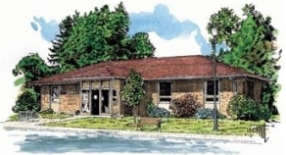
Sherrill Kenwood Library News
Visit our facebook page or www.sherrillkenwoodlibrary.org, or call (315) 363-5980 for more information.


Tuesday Toddler Time is held at 11am through mid- May. Join us for stories, songs, smiles and crafts.

The Unlikely Pilgrimage of Harold Fry, Wednesday April 4, 6:30pm- All are welcome to join our group.


National Library Week, April 8-14-Stop in to see all we have to offer. Your library card grants you access to a world of wonderful things.


“My Father’s Adirondacks,” Tuesday April 10, 6:30pm- presented by wildlife photographer Sue Kissel.


National Scrabble Day- Friday April 13- We will host scrabble games from 1-5pm.

Puerto Rico: A deeper look, Wednesday April 18, 6:30pm- presented by relief worker, Heather Beebe.

Community Art Wall Schedule- March- VVS Schools, April- Sue Kissel Adirondack photography, May- Cornue’s Children’s Corner, June- Linda Evans’ art class students.

The Friends of the Library will meet Thursdays- March 22, April 26 & May 24 at 6:30pm.


We have two admission passes to give away for The Wild Animal Park. Read a book about an animal, bird or reptile, write a book report and enter a drawing to be held May 17. Entries will be accepted April 1-May 16.
We are also pleased for the 3rd year to have two admission passes to give away for Enchanted Forest Water Safari. Enter our book report drawing April-June. The drawing will be held June 21st.


Monday April 23- Children’s Movie, 1:30pm & Creative Coloring, 1-5pm.
Tuesday April 24- Celebrate Earth Day & National Jelly Bean Day with stories and crafts, 1-4pm.

Wednesday April 25- Our 1st “Egg Drop Challenge” will take place at 1pm, sponsored by the Friends of the Library. Can you make a container that can protect a raw egg from a fall from the bucket of the Sherrill Power & Light truck? Put your STEM (science, technology, engineering, math) skills to use. Pre-registration forms must be filled out prior to the event.

Thursday April 26- 2nd Annual Stuffed Animal Sleepover, 6:30pm- Leave your stuffed animals with us for the night. Join us for a bedtime story and snack.

Friday April 27- Snap & Squishy Circuits Workshop, 1pm- Come investigate how circuits work.

Composting- Gardening season will soon be here. Learn more Thursday May 3 at 6:30pm, presented by the Oneida Herkimer Solid Waste Authority.


3rd Annual “Spring” for Books Thursday May 17, 11am-8pm- Help us add 100 books to our collection! Gypsy Girl Wood Fired Pizza & The Cremeria will sell food, E.A. McAllister Elementary music students will perform at 1pm. The Friends of the Library will offer face painting.

Armed Forces Story Time- Saturday May 19, 11am

Mahjong- Please contact us if you’re interested in playing! A group is forming.


Donations are accepted during library hours only. Please do not leave items outside or placed in the book drop. Materials must be less than five years old.

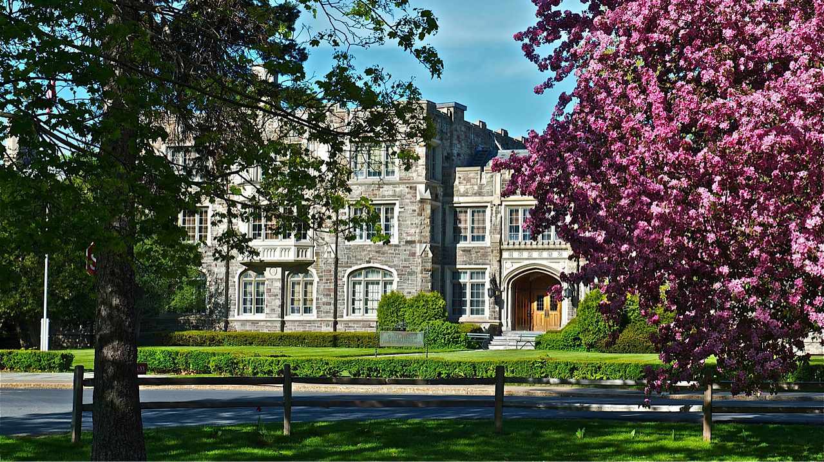

News from Kenwood Community Properties
The old Oneida Limited Sales Office has seen exciting changes. It’s currently in the third year of a ten-year plan to repair or replace all stone work. We apologize to those seeking a location to take prom photos as the front stairs are in bad shape, but they are on the short list of items to be addressed. Over the past couple years a few parts of the roof have been replaced and more will be in the coming years.
Inside, there have been major changes which may make areas unrecognizable to people who worked there. The first floor has been completely remodeled to temporarily house Madison County Courts while the courthouse in Wampsville undergoes an 18-month renovation to become ADA compliant. When the courts move back to Wampsville the space will be rented out to smaller tenants.
The ground floor has multiple tenants. FPM Remediation Inc., an environmental company, is located on the eastern and southern side. The photography studio was converted to a studio for Bloom Yoga. Natural Alternatives, a day spa offering facials, massages, acupuncture and more is located off the main hall. BJK photography, a company that takes school, sports and other pictures is located outside the renovated cafeteria. There are also a couple of other businesses and there’s space for future tenants.
The Blue Room now looks more like a lounge, complete with video games, ping pong and poker tables, a couch and TV. Next door is an exercise room with ellipticals, bikes, a treadmill and weight machine. These areas are open to tenants and designed as community space for tenants of future apartments. The top two floors will be converted to apartments designed with retirees in mind. They’ll have one or two bedrooms with safety features to accommodate any specials needs for seniors. The plans are under review and construction should be underway soon. For more information contact Jody Hicks at (315) 663-1850 or visit kenwoodcp.com.

Sherrill Garden Club News
Mark your calendar for the annual Plant Sale Saturday, May 19, 8am-1pm at the CAC! The club will offer perennials from members' gardens, houseplants, annual flowers and vegetables, herbs, wave petunias, and many other plants. They’ll also have a bake sale and a tag sale of household items. Attend early for the best selection!
On Tuesday May 1 the club will meet to plan the logistics of the plant sale and a business meeting follow. On June 5, Jim Kahler, member of the Syracuse Rose Society and Consulting Rosarian for the American Rose Society will present, "Growing Roses in Upstate New York-a Lesson in Rose Culture." Many gardeners believe roses are difficult to grow. Jim will dispel fears and myths about growing roses and show gardeners that anyone can grow beautiful roses. Meetings take place at the Sherrill Library at 7pm. Members of the community are always welcome to attend presentations and learn about the mission and activities of the Sherrill Garden Club!
Events at Plymouth Alliance Church
169 Kinsley Street
-Sunday School- 9:15am each week, all ages
-Worship Service- Sundays at 10:30am
-Wacky Wednesdays- 4/18 & 5/16- Dinner, games, and a Bible talk for elementary school children and their parents. Dinner- 6-6:45pm, Gym time- 6:45-7:45pm.
-Vacation Bible School 2018- 7/30-8/3
Check out www.plymouthalliance.com & Facebook “The Plymouth Alliance Church”





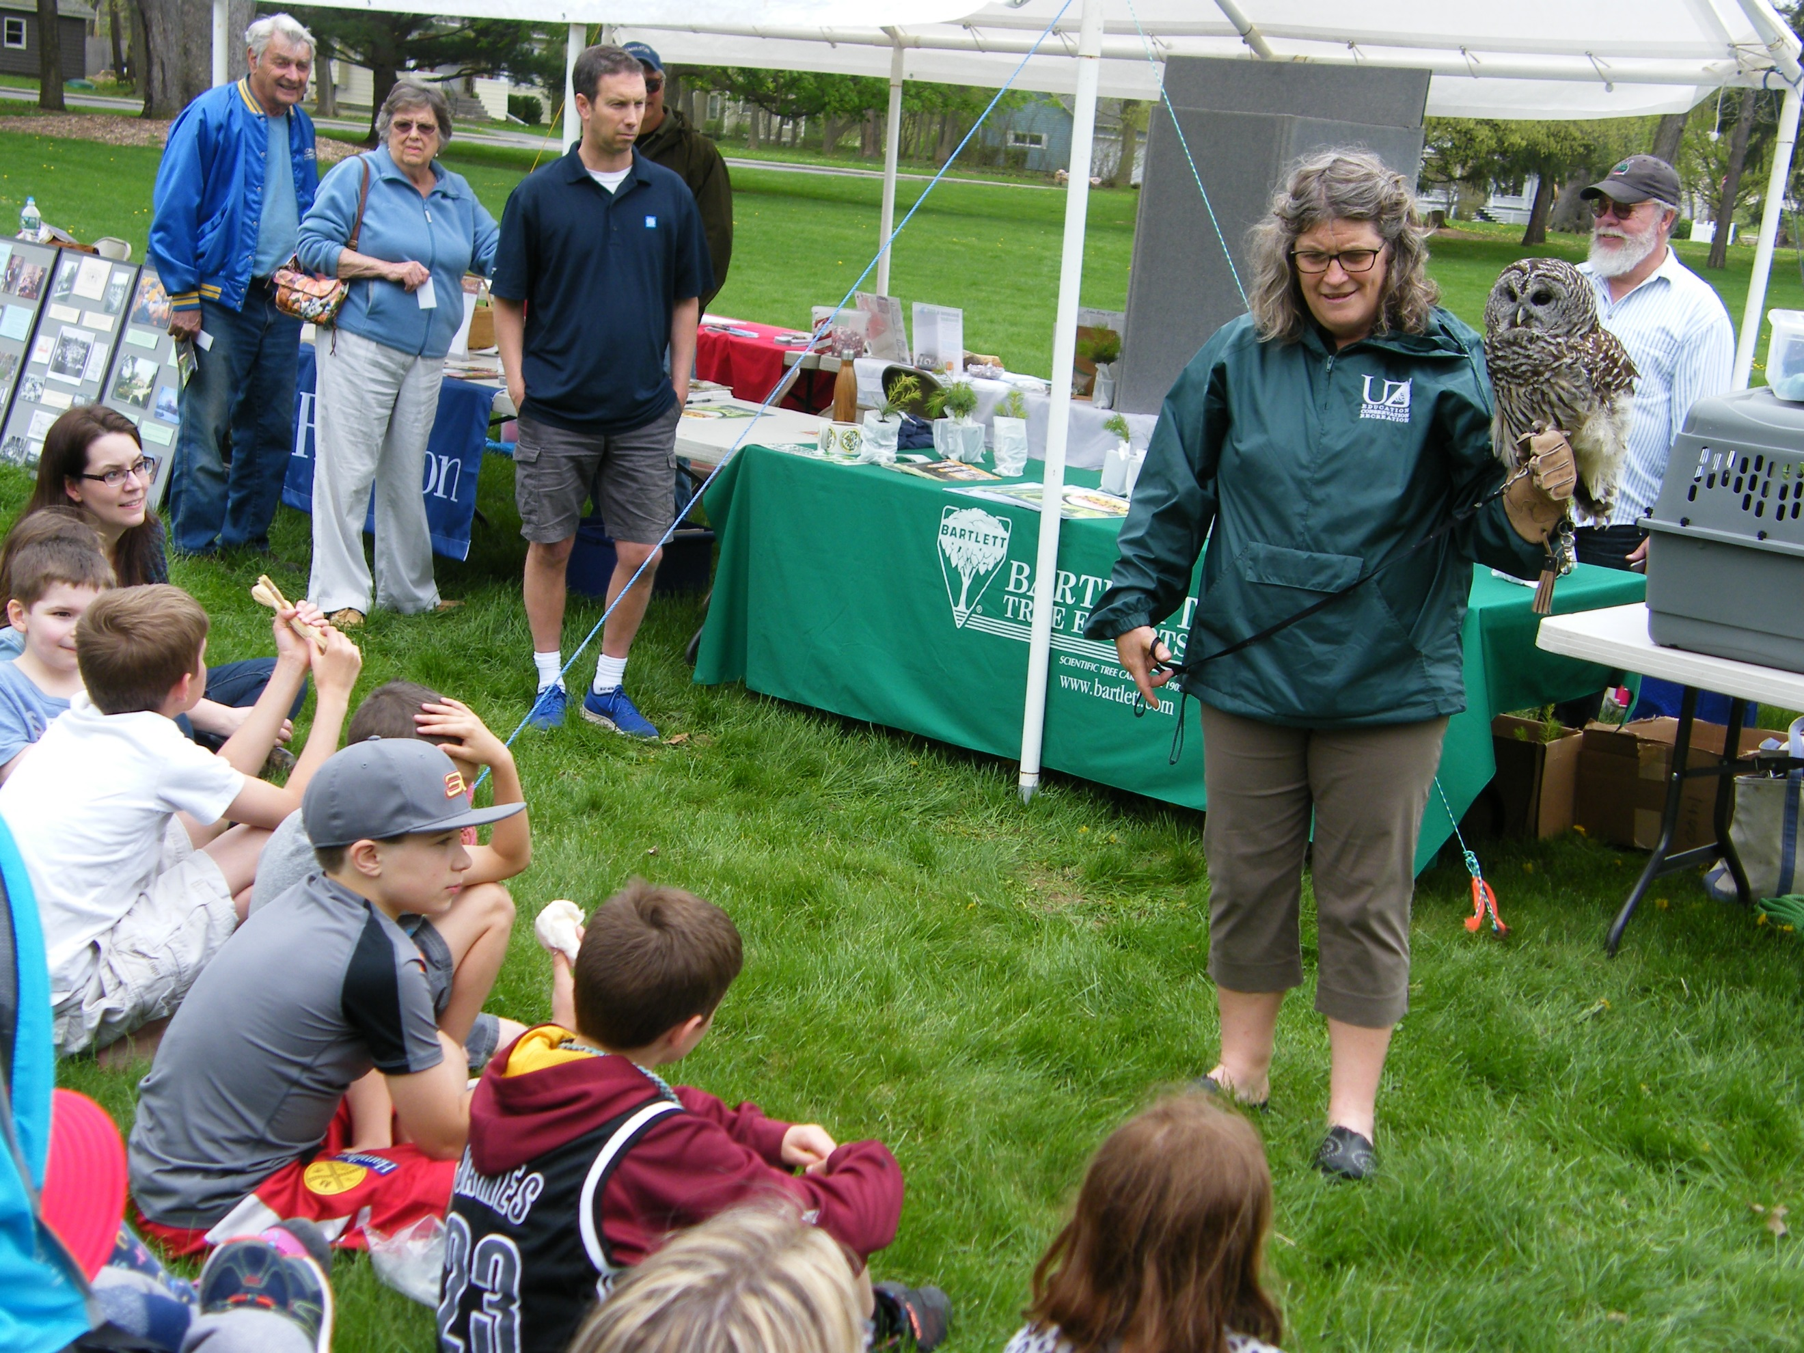
Arbor Day at the Mansion House April 28, 11am-2pm
The Oneida Community planted many varieties of trees. Today there are over thirty varieties! Enjoy free nature-based activities and demonstrations for all ages.

Sherrill American Legion Post 230 Events
Easter Egg Hunt- Saturday March 31, 2pm
Chicken BBQ- Sponsored by Sherrill Legion Bowlers- Saturday April 14, 12pm-sold out, $10/chicken, baked beans, roll, salt potatoes
Mother’s Day Brunch- Sunday May 13, 8am-12:30pm, Enjoy eggs, bacon, sausage, home fries, french toast, beef hash, coffee, tea & milk, adults- $10, seniors- $9, kids 5-12- $5, under 5 free

Sherrill Memorial Day Parade- New Route- Monday May 28

Sherrill Legion Post 230 works with the City of Sherrill to coordinate the Memorial Day parade. The parade will follow a new route this year! Lineup will take place in the parking lot and greenspace in front of the Sherrill Community Activity Center at 139 East Hamilton Ave. The parade will start at Sherrill Road and East Hamilton Ave and continue down Sherrill Road to Memorial Park across from Sherrill City Hall. Anyone who wants to participate can park and lineup at the CAC at 8:30am. The parade will start at approximately 8:45am. There will be a ceremony in Memorial Park following the parade at approximately 9am. After the ceremony everyone is invited to the Legion for free food and drinks. Plan to participate by walking with your organization or watching the parade!

Noyes Park Baseball

Junior & Senior Legion and Silversmiths teams will hold games and practices at Noyes Park May-July. Visit www.sherrillny.org for schedule information.

Food $en$e

The Food Bank of Central New York’s Food $en$e program offers a monthly box of groceries for $20.50 that includes 4-5 meat items, 4-5 pantry items and 2 produce items. There are no age or income restrictions to participate and monthly specials can be purchased in addition to the basic unit. There are many locations across CNY and at the Church of the Holy Family at 4343 Peterboro Street in Vernon a representative takes orders and answers questions the first and third Monday of each month from 5-6:30pm and the first and third Friday from 9:30-11am. Stop by or email brjuniper1980@twcny.rr.com for more information.

Police Department Reminders
-Overnight parking on City streets is prohibited through April 30 from 2-7am.
-Studded tires must be removed by May 1.
-Please be aware of scams. Do not give out information unless you can verify the request.
-Please license your dogs, honor leash laws, and pick up after them.
-Be aware of pedestrians. Pedestrians are encouraged to wear reflective gear after dark.
-Keep car doors locked, especially at night.

Tax Roll Information
The Tentative Tax Roll will become available May 1. It may be examined at City Hall during normal work hours. In addition, the City Assessor will be in attendance with the Tentative Roll Tuesday May 1 6-8pm, Wednesday May 2 9-10am, Thursday May 3 9-10am and Saturday May 5, 9-9:30am at Sherrill City Hall, 377 Sherrill Road. The Board of Assessment Review will meet for Grievance Day May 15 2-4pm and 6-8pm at City Hall to hear and examine all complaints in relation to assessments. Grievance forms may be obtained at City Hall and should be returned to the Assessor by May 15. The Assessor has the authority to stipulate assessment adjustments prior to the BAR meeting at 2pm on Grievance Day. Please contact the Assessor or City Hall with questions.

Mark your calendar for our summer events!
Find details at www.sherrillny.org
Swimming Pool Opens- June 16
Summer Concerts- June 26-August 28
Playground Program- July 2-27
Tennis Camp- July 9-23
Fireworks Weekend- July 26-28
-Golf Tournament- July 26, 5:15pm
-Festival- July 27, featuring Last Left, 6-10pm
-5K Race & Kids Fun Run- July 28, 7:30am
-Fire Dept Chicken BBQ- July 28, 12pm
-Concert & Fireworks Night- featuring Soul
Injection, July 28, 7:30-10pm
Movie Night- August 14, 6:30-10pm

City of Sherrill
377 Sherrill Road
Sherrill, New York 13461

Rough to be a Robin!!!!!


