Robert A. Comis, City Manager
Michael D. Holmes, Comptroller/City Clerk Christopher Bailey, Supt. Public Works Robert Drake, Police Chief
Sara Getman, Recreation Supervisor
Kevin Mumford, Supt. Waste Water Treatment
Robert Mumford, Supt. Power & Light

CITY OF SHERRILL
COMMISSIONERS
William Vineall, Mayor Jeffrey Gilbert, Deputy Mayor Thomas Dixon
Patrick Hubbard Jason Merrill

377 Sherrill Rd.  Sherrill, N.Y. 13461  Telephone: (315) 363-2440  Fax: (315) 363-0031  www.sherrillny.org

City of Sherrill Farmers Market 2017
Tuesdays 3-7pm, May 16-Early Fall

March 21, 2017

Dear Vendor,

We hope you will join us for the 2017 City of Sherrill Farmers Market! Last year we had some great new vendors and our residents really enjoyed shopping at the market. We’re looking forward to even more growth this year.

We are planning some special events this year to draw even more customers to the market including:
-activities for kids
-an event with the Sherrill Library
-partnerships with local organizations
-a senior farmers market coupon day
-our summer concert series

We’ll be promoting these events via our website, newsletter, email list and facebook page to draw customers to the market. We have a great schedule lined up for our Tuesday evening summer concert series each week beginning at the end of June and running through August. Concerts take place from 6:30-8:30pm in the gazebo in Reilly-Mumford Park. Vendors who wish to stay open later during the concerts may do so.

We look forward to a fun summer in Sherrill and we’d love for you to be part of our market. Please read our guidelines and complete and return the application. Please contact me with any questions, (315) 897-0139 or sgetman@sherrillny.org.

Sincerely,

Sara Getman
Recreation Supervisor

2017 Sherrill Farmers Market Information and Guidelines

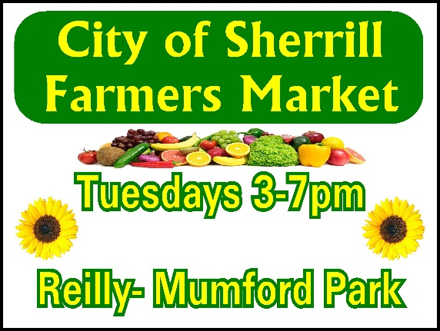

Dates: Tuesdays, 3-7pm, May 16-Early Fall
*We’ll decide a closing date, probably in mid-September based on weather, etc.

Location: Sherrill Skating Rink (adjacent to City Hall and Reilly-Mumford Park)
377 Sherrill Road, Sherrill, NY 13461

Guidelines: -Vendors must submit an application and pay required fees to obtain permission from the City of Sherrill to participate in the Farmers Market.

-Vendors may sign up for the season or individual weeks. Vendors are encouraged to sign up for the season as vendor consistency helps to build the market. The market is held rain or shine. In the event of severe weather the City may cancel the market. Vendors who need to miss a market must contact Sara Getman, sgetman@sherrillny.org or 897-0139.

-Please indicate the items you plan to sell in your application.

-Vendors must display a sign that includes the name of their business and comply with all City of Sherrill, NYS Department of Agriculture and Markets, NYS Department of Taxation and Oneida County Department of Health regulations. Each vendor is responsible to secure and maintain proper licensing required by all regulatory agencies. Licenses must be available at the site for inspection.

-Each vendor will be assigned a space. All activities must be conducted in an orderly fashion and the space must be kept neat and safe. Each vendor must clean all material from their area at the close of the market.

-The City of Sherrill reserves the right to revise these guidelines and to revoke the permit of a vendor if necessary.

City of Sherrill 2017 Farmers Market Application
Contact Person Name
Business Name
& Type
Mailing Address
Email
Phone

Please list and describe all items you wish you to sell. Please attach a crop plan or additional sheet if necessary.
Please list any special requests.

2017 Fee Schedule

Season: ______ $50

Daily rate- $12/day
Please list the dates you plan to attend: __________________________________________

______ number of days x $12/day= $______

Electrical Outlet (rate for season/day use): ______ $20
Please list the items you plan to use the outlet for and the wattage listed on the information plate:
Item Wattage

_______________________ _______________________

_______________________ _______________________

I acknowledge that I have received, read and agree to comply with all guidelines governing the 2017 City of Sherrill Farmers Market. I certify that the information above is accurate.

Vendor Signature __________________________________________________ Date:_____________

Please complete and return this application with payment to: City of Sherrill, Attn: Sara Getman, 377 Sherrill Road, Sherrill, NY 13461 We will review your information and contact you about our market. We look forward to working with you. Thank you!

